

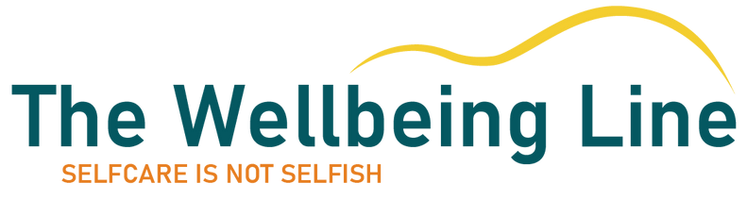
Welcome Pack
Welcome to your new role!
In your welcome pack, you will find...
Introduction........................................................................page 2
Who we are.........................................................................page 3
How The Wellbeing Line can support you.............page 4
How stress can build up.................................................page 5-6
Why it is important to look after you..........................page 7
Developing self-compassion.......................................page 8-10
Looking after you in your new role............................page 11-16
Contact us...........................................................................page 17
Other useful contacts in your organisation............page 18-19

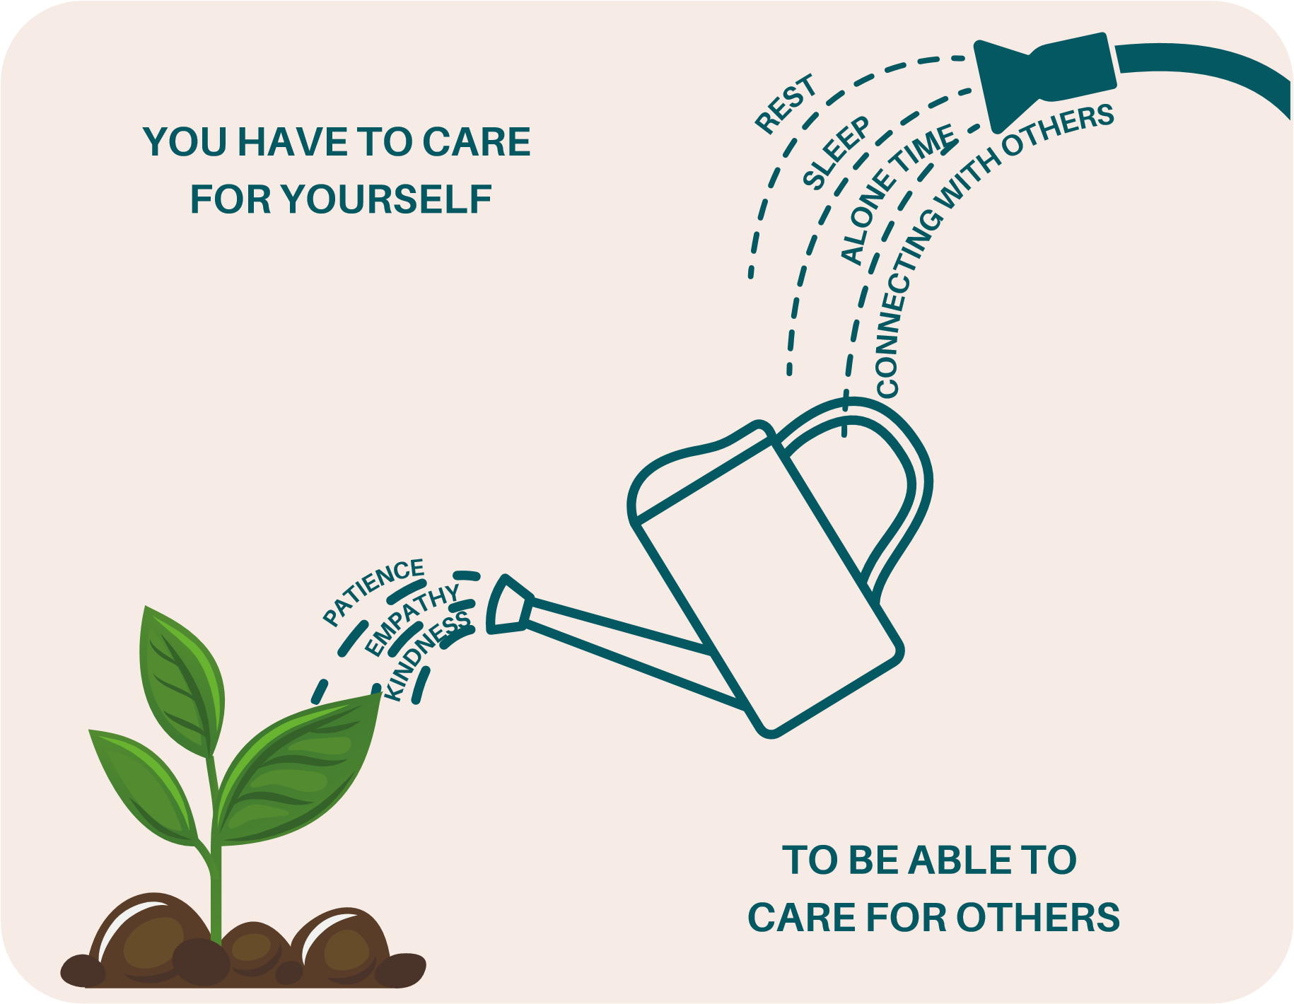
Introduction
Welcome to your new role!

This pack includes:
information
resources
handy tips
contact numbers

To help you look after your health and wellbeing as you start your new role and beyond.

Who we are
The Wellbeing Line is a mental health and wellbeing hub, set up in response to the coronavirus pandemic, to provide support to health and social care staff in a holistic and responsive way. We are now locally funded by the Integrated Care Board (ICB).
No problem is too small.
If you are feeling overwhelmed or stressed, worried, anxious or low in mood - if you are not sleeping well
or you just don’t feel like your usual self - reach out.

Our purpose:
Unlocking confidential mental health and wellbeing support for anyone working in health and social care in Gloucestershire. Encouraging open discussions about mental health and wellbeing.
Normalising people's experiences and helping them access the right support for them.
The Wellbeing Line is FREE to access, and you can self-refer by calling 0300 421 7500, emailing hello@thewellbeingline.co.uk, or filling out the callback request form on our website www.thewellbeingline.co.uk. There are no forms to fill-out or waiting lists.
Please note, The Wellbeing Line does not offer crisis support or ongoing 1:1 support.

How The Wellbeing Line can support you
The Wellbeing Line is independent from your employer, occupational health, GP and HR. We offer a confidential, safe space for you to talk through any difficulties you may be experiencing, whether that is related to work, personal circumstances, emotional wellbeing/mental health concerns or the ongoing impact of COVID.
APPROACH
INDIVIDUAL
TEAM
LEADERSHIP
ORGANISATIONAL
Independent
Compassion
Focused
Trauma Informed
Collaboration
Connection
Consultation
Culture Change
Consultation
Support tailored to
team needs
Psycho-education
Sessions

Mental Health
Workshops
Mental Health
Webinars
Consultation to
1:1
Team Leads/
Managers
Mental Health
Specific Training
Peer Connecting
Sessions
Compassionate
Leadership
Conversations
Strategy
Development
across ICS
Bespoke Projects
Subject Matter
Experts
Central Point of
Contact
Data Collection
and Triangulation
SUPPORT FOR YOU
No problem is too
small
Personal or work-
related issues
Free
Confidential
Responsive
Independent of
your employer
All support is
tailored to your
needs
What happens when you contact us?
We will give you time to discuss what has been happening for you, then work together to make sense of what is going on and think of ways to help you move forward.
As well as individual support, we provide support for teams and team-leads too. We offer tailored support that is targeted to the specific needs of the team. Team leads are welcome to call or email if they are concerned about a colleague and/or if they would like to think about ways to support their team.

How stress can build up
We know that working within health and social care professions can be rewarding, but challenging at times. Situations within our workplaces may cause us to feel stressed and anxious.
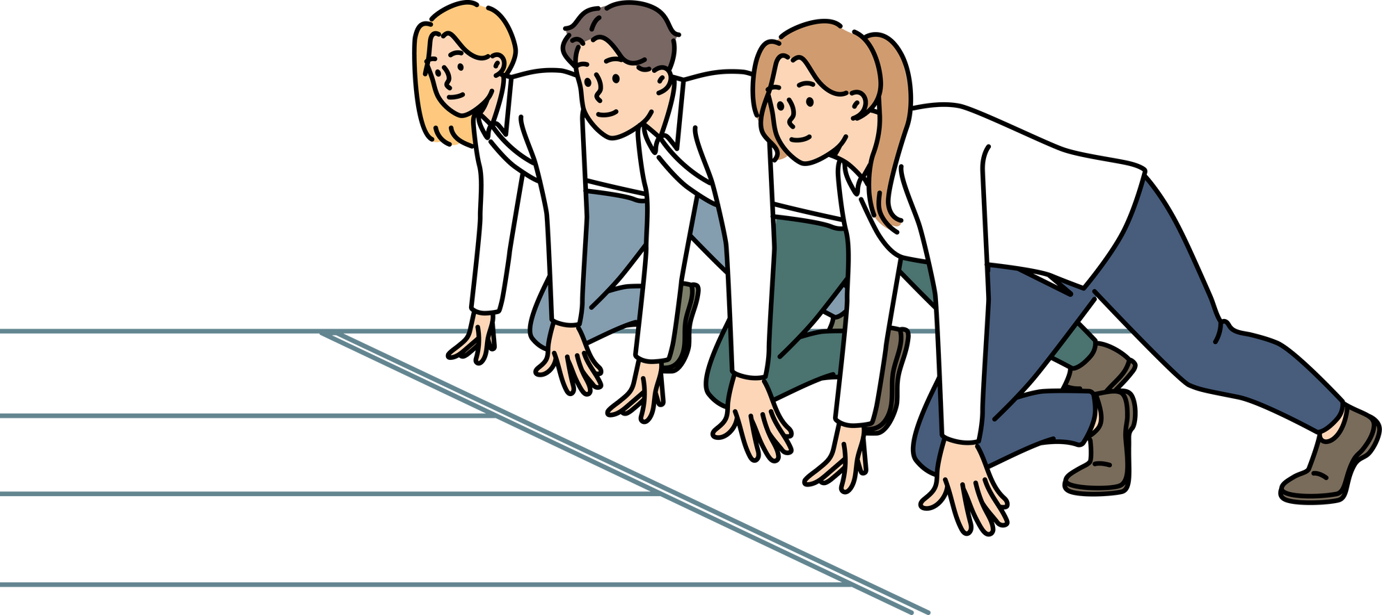
Stress is a normal physiological response and, in the short-term, can be helpful. It helps us assess risks, keeps us safe from danger, motivates us and helps us manage changes.
Like runners before a race, shortterm adrenaline and stress can help us and we can thrive on it, provided we can rest and recuperate after.
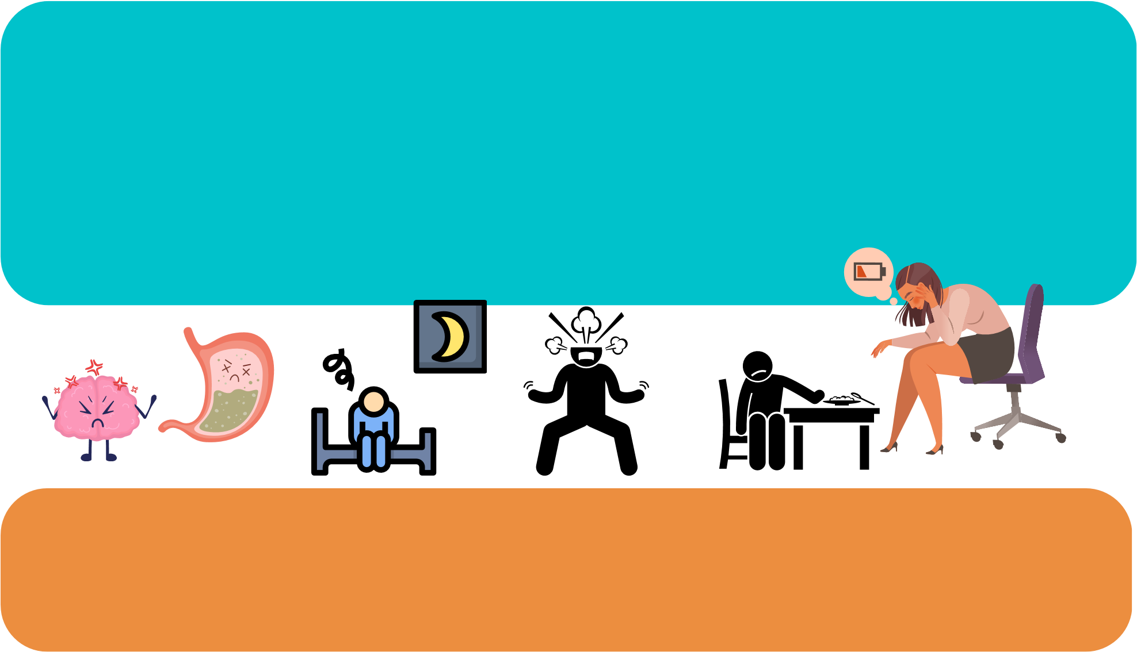
However, when the feelings of stress continue, this can have a negative impact on us both physically and emotionally. We know that the feelings of stress can build up over time. Whilst there might be one event that causes us to feel stressed, it may also be the combination of a number of events that happen over time, which can ultimately lead us to feel burned out.
S
Stress can show up in many different ways and it is important to recognise when it might be showing up for you. What are your early warning signs?

How stress can build up
We all have capacity or ‘reserve‘ to deal with challenging or stressful
situations.
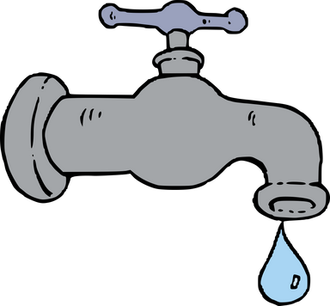
As we go through life or a period of stress, this bucket gets filled and
can get close to the top.
What fills up your stress bucket?
What helps you let it out?
This can mean that our capacity or reserve to deal with new stressors or daily hassles is reduced.
What can then happen is the bucket ‘over flows‘. This overflow can result in feelings of anxiety, stress, low mood, irritability.

Why it is important to look after you
We need to find ways to release the build up of stress by bringing awareness and compassion to our feelings. Recognise that we are struggling. We then need to connect with what soothes us and look after ourselves again.

By understanding and bringing awareness to these feelings we can
begin to recognise when we need to look after ourselves, when we
need to treat ourselves with compassion, and when we might need to
reach out to others for support.

How to check-in with yourself
START
What am I feeling?
How strong

is this

feeling?
Where am

I feeling it
in my body?
What is
this feeling
telling me?
What do
I need
right now?
What little
step can I
take to meet
my need?

Developing Self Compassion
What is compassion and why is it important?
Being part of a caring profession, a large part of our job involves offering care and empathy for others. Doing this without offering compassion for ourselves can leave us feeling stressed, and at risk of burnout. Developing compassion for ourselves can bring our emotions into a helpful balance that increases our sense of wellbeing.
Offering and receiving compassion to and from yourself
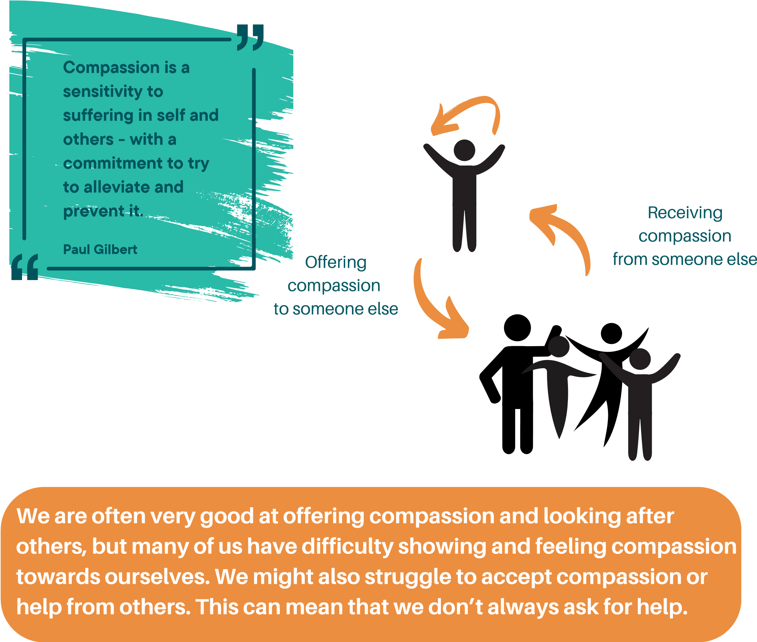

Developing Self Compassion
Paul Gilbert’s model suggests that we have three emotion regulation systems. These systems work together to help us manage life's ups and downs.
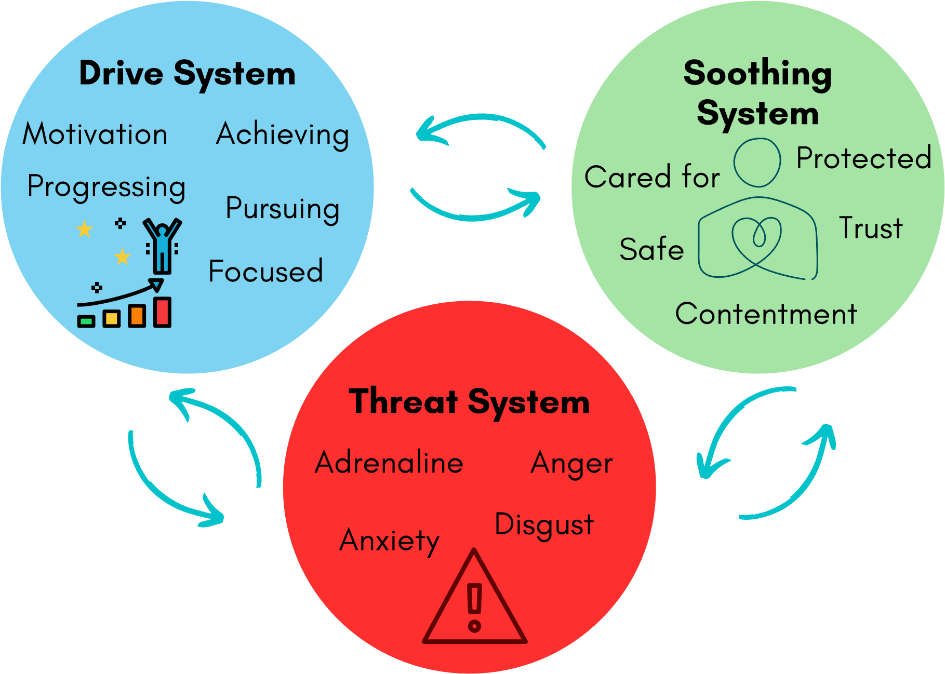
Although we might not realise it, a lot of us tend to spend our time in the threat or drive systems. In order to manage this, we focus on “doing”. This might lead us to respond reactively, not allowing ourselves time to slow down and think. The threat and drive systems are high energy systems. When we spend a lot of time in both, we may drain our energy reserves, and this can lead us to feel ‘burnt out’.

Developing Self Compassion
When we notice we are struggling, we can: REDUCE RED (our threat system) by slowing down, recognising we are in our threat system and thinking about what we can do to remove stressors or ask for help.
Hobbies

Build a routine you enjoy
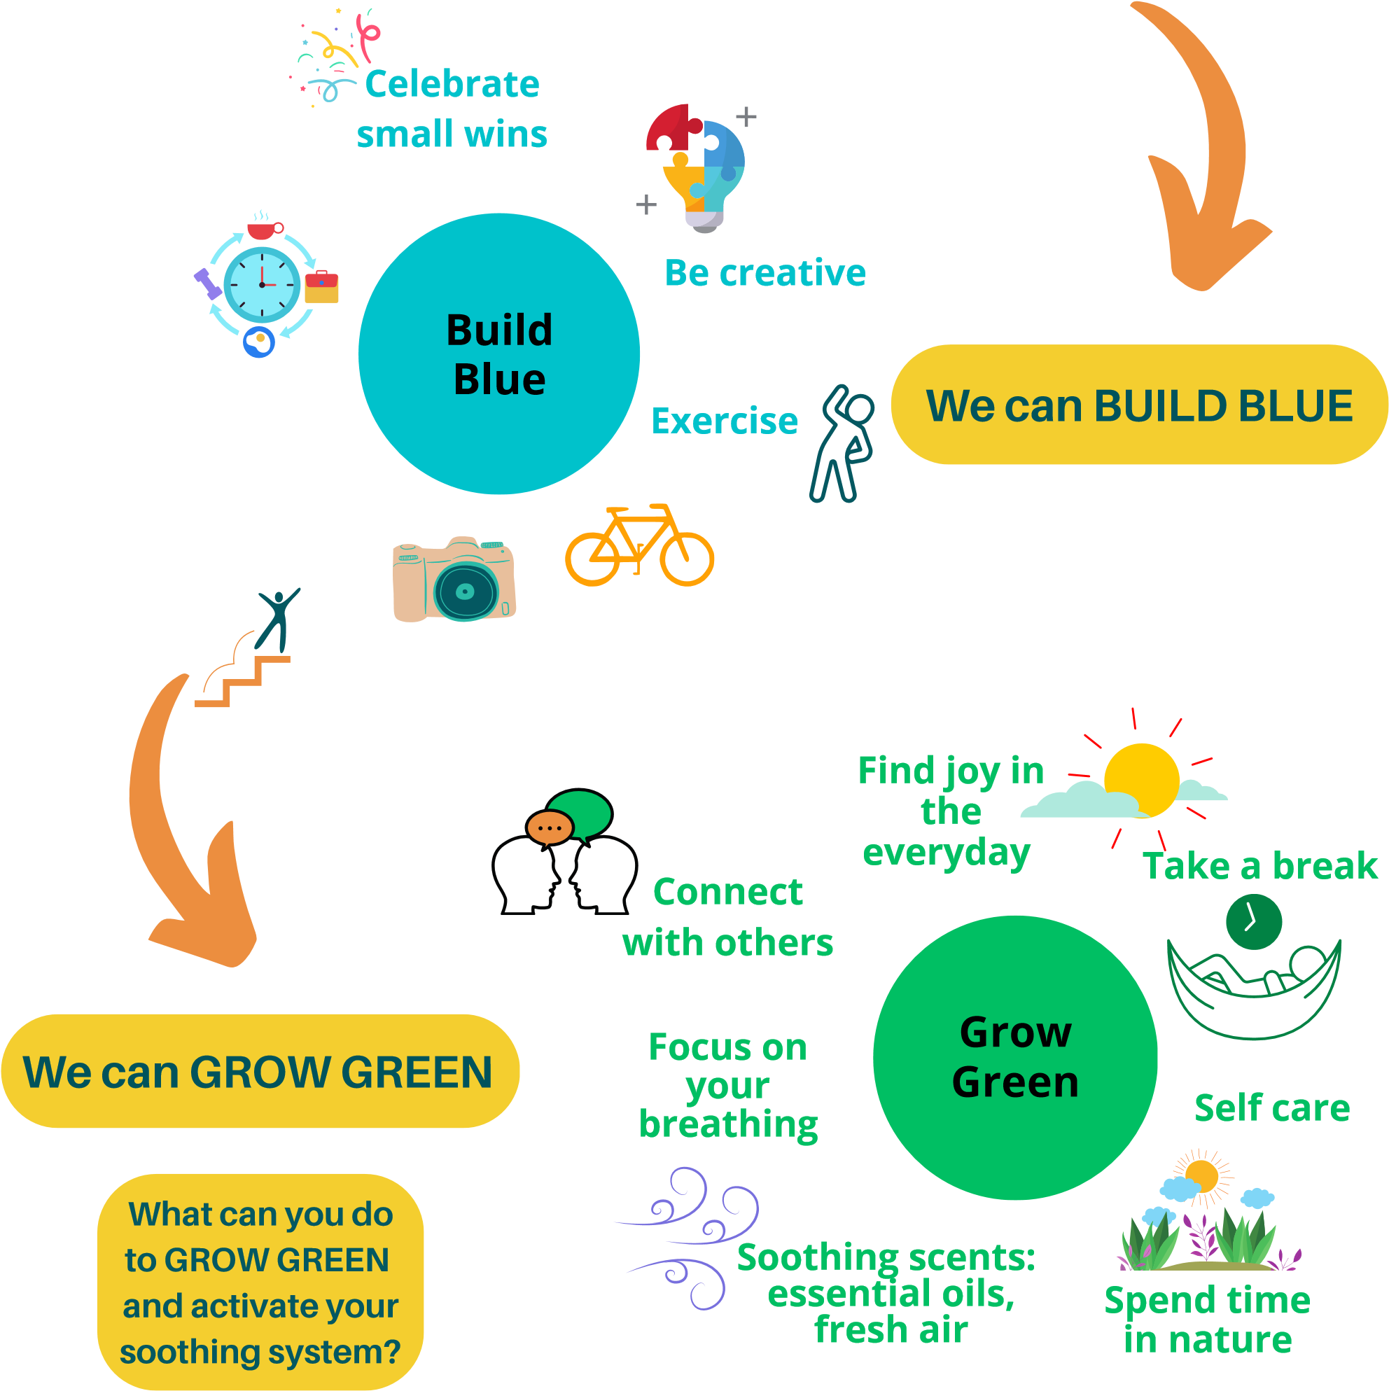

Looking after YOU in your new role
Whether you are starting a new role or you have been in your role for some time, work can sometimes feel overwhelming. Thoughts of 'am I good enough?', 'what if I make a mistake?' or 'there is so much to remember', are all normal thoughts to have. However, our thoughts can also trigger our threat system, so it is important to make sure these and other unhelpful thoughts do not become common or comfortable in your mind, here are a few handy techniques to practice regularly:
Keep a note of things that are going well in your new role, such as if someone gives you good feedback. It can be really helpful to look back on these achievements when you are experiencing these thoughts.
Practice some quick and simple breathing or relaxation techniques, such as the examples on the next page. These techniques help us to clear our mind and think more clearly. This can help us to manage unhelpful thoughts and to cope in stressful situations.
Think about creating an after-work routine to help you switch off from work. Changing out of work clothes can be helpful. If you can, try to connect with nature, for example going for a walk or sitting outside with a cuppa. Perhaps do something you enjoy like listening to music, reading or making time to connect with friends/family.

Below are a couple of helpful techniques that can help calm the mind and body. They only take a couple of moments, so practicing them regularly can maximise their impact:
Connecting with your breath and finding your own soothing
rhythm can be a great way to slow things down and bring yourself
into the present moment.

You might like to try a simple grounding technique which focuses on your 5 senses. In moments of stress or panic this can quickly & effectively slow things down & bring you back to the present moment.
5 Senses Activity
5 things you can SEE
4 things you can TOUCH
3 things you can HEAR
2 things you can SMELL
1 thing you can TASTE

You can also try a simple breathing technique called rectangular breathing, which involves looking for something in the room that is shaped like a rectangle. If you cannot see anything, simply close your eyes and imagine a rectangle in front of you.

Starting bottom left corner:
Breathe in through the nose to the top of the rectangle
Breathe out through the mouth along the top of the rectangle Breathe in through the nose down to the bottom of the rectangle
Breathe out through the mouth along the bottom of the rectangle.
Do this as many times as you need to feel calm

OUT
IN
OUT
IN

Rectangle Breathing

If you find your mind busy and not able to switch off, try keeping a note pad to write down what’s on your mind. It can also be helpful to follow any unhelpful thoughts or worries you write down with 3 things you are grateful/thankful for.

Taking a break during your working day is important. The science tells us that taking movement breaks has physical health benefits by reducing the negative effects of sitting. Taking breaks can also increase your motivation and productivity, and improve your learning.
Here are a few of our favourite effective break ideas:

Exercise
A regular stroll can increase blood flow to the brain, enhance the connectivity of important
brain circuits, combat age-related declines in brain function and improve memory and cognitive performance.
Nature
Noticing the sights and sounds of nature can help you recharge. Natural environments
reduce stress and can replenish your cognitive resources. Find plants, fresh air, a fish tank, or a fountain. Sit down, take a deep breath, and notice the details of nature.

Eyes

Doing 20-20-20 eye breaks is a straightforward way to alleviate eye strain and fatigue. Every 20 minutes, stare at something
20 feet away, for 20 seconds. This requires blood flow to brain areas that are not related to sustained attention.

Looking after YOU in your new role
Making sure you are getting enough quality sleep is vital for physical and mental health. This is especially true if your role involves shift work. Here are some of our favourite sleep tips:
If you are struggling to get to sleep, try not to lie there longer than 20-30 minutes trying to get to sleep. Get out of bed, keep the lights low, do something relaxing such as reading for a few minutes. This helps reset the bedtime cycle so that when you get back into bed, your brain can relax and allow you to fall asleep.
Our brains love routine and association and this is important for sleep. Even if you cannot sleep and wake up at the same times due to shift patterns, creating a consistent bedtime routine can be really helpful. Routines can help our brains learn a link between these actions and the fact that it's now time to sleep.
Avoid phones and screen use before bed as this can keep our brain’s active and make it harder to fall asleep.
Avoid caffeine in the hours before bed as it can contribute to difficulty falling asleep by disrupting your circadian rhythm.

Looking after YOU in your new role

When starting a new role, it is important to find out some key information about how your team/organisation will support your health and wellbeing:
If you don't already have one, find a buddy who is also new or a newer member of the team - someone you can turn to as you settle in.
Speak to other team members or your manager to find out what they might be doing to support staff health and wellbeing - see if there is anything you can get involved in which might help you get to know your new colleagues and/or your new role.
Many teams have Health & Wellbeing Champions - ask your manager if your team has one and introduce yourself if you haven't already met them. You can ask them to point you in the direction of any support you might need.
Scan the QR code to find out more about Health & Wellbeing Champions:
It will take you time to settle in to your new role and it’s important to look after yourself and be kind to yourself as you do. Please ask for help if you need it and remember that ‘selfcare is not selfish’.
Contact us
Email:
hello@thewellbeingline.co.uk
Freephone:
0300 421 7500
Our freephone support lines are open between
9
am to 4.30pm, Monday – Thursday and
between 9am to 12pm on Friday.
If you prefer to email in the first instance, then we will aim to
respond within two working days to arrange a telephone call.
Prefer us to call you?
You can request a call back on our website:
htpps://thewellbeingline.co.uk, and we will aim to get back to you
within two working days.

17

Other useful contacts in your
organisation
18
Other useful contacts in your
organisation
19

